Desire the power of all achievement

Identify Your Ideal Client. ...
Discover Where Your Customer Lives Know Position Yourself as the Answer Try Direct Response Marketing
Build Partnerships

Increase Your
Business With Us

.
Desire Technologies is a global Marketing, Advertising, Digital Marketing , Web design and Mobile App Development Company. We are a platform for personal growth and creative self- expression. We are an independent creative and digital marketing agency established in 2009. We collaborate with brands to accelerate their growth.

We at Desire Technologies are committed to provide you the best solution in Digital marketing, Regular Marketing, Branding and also provide best support in the recent Industry.
We develop innovative models for traditional experiences and craft unexpected approaches to immersive digital experiences, social media engagement, and community management.

We have expertise in web design, web development, ecommerce, Search Engine Optimization (SEO), Search engine marketing (SEM), Social Branding and online marketing solutions. Our online marketing strategies ensure the maximum exposure of your business. We’re continually perfecting the art of partnership. Through our commitment to measurable results, a collaborative approach, and expertise in emerging technologies, there’s a reason why Desire Technologies is Kolkata’s abundantly awarded, full-service advertising and marketing agency.

- If you are a Small Business, SSI Manufacturer, Exporter, Wholesaler, Retailer, Consultant, NGO, School, College, Hotel, Travel & Tours Operator, Caterer, Restaurant, Club or Association, and for any other Big or small entity we have developed a special low cost Marketing Design and Package catering specifically to your needs and your budgets, to make it affordable year after year.
- We would be happy to design a web site for your business or professional needs. Please do contact us, we are sure we will have specific solutions that fit your budget and target markets.
We have valuable clients not only in our Country India but also in UK , USA, UAE, Middle east, Malaysia Singapore and many more countries. We have our own team of skilled php android IOS Developers in India, Having an experienced team of skilled SEO professional, we have created our niche as a top 10 SEO company in India.

We breathe life into your company story, developing branding that advances your message and
forms a distinct image. While each phase moves your brand somewhere new and exciting, we continuously infuse direction from what we’ve learned about where the brand has come from,
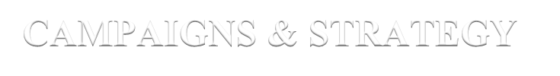where you’d like the brand to go, and how the new brand image will impact consumer behavior.

Positioning Brand DNA Messaging Logo Mark
Brand Development

We design functional interfaces for an aesthetically pleasing digital presence that helps tell your story and boosts brand performance.
Mobile/Web Apps E-commerce UX/UI Design Corporate Presence
Robotics

We take your brand, platform, and the business you’ve worked so hard to build out into the world through campaigns. And we’re not just throwing you to the wolves, mind you, but rather preparing you to go to market with a sound lead generation strategy and the metrics to back it up.

Marketing Strategy Media
Experiential Digital SEO/SEM
Lead Generation

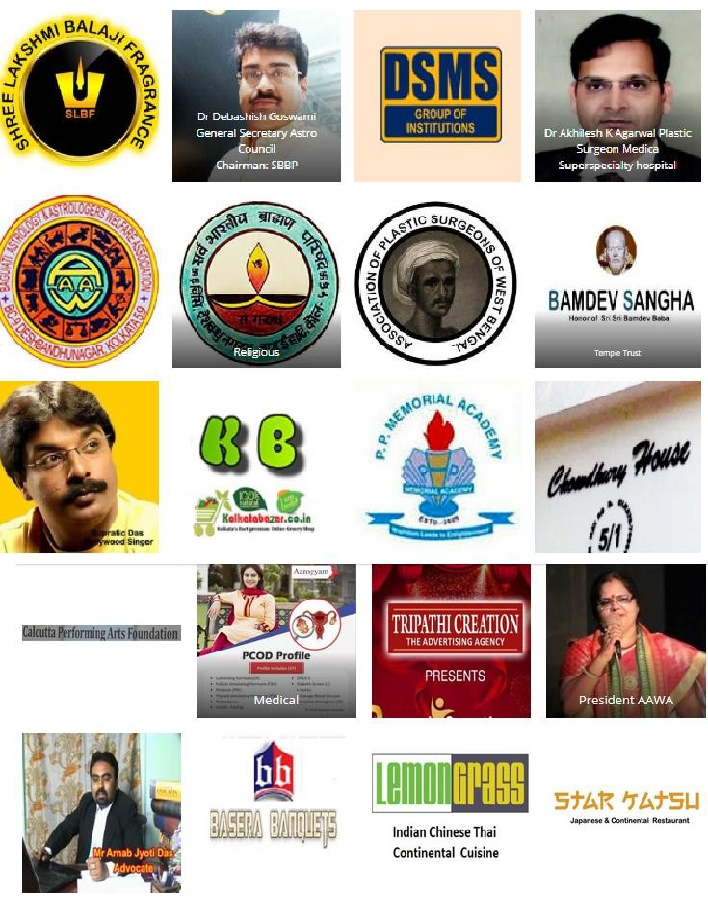

Industries We Serve From Coast to Coast

For each and every industry we embrace, we are deeply experienced and highly resourceful.

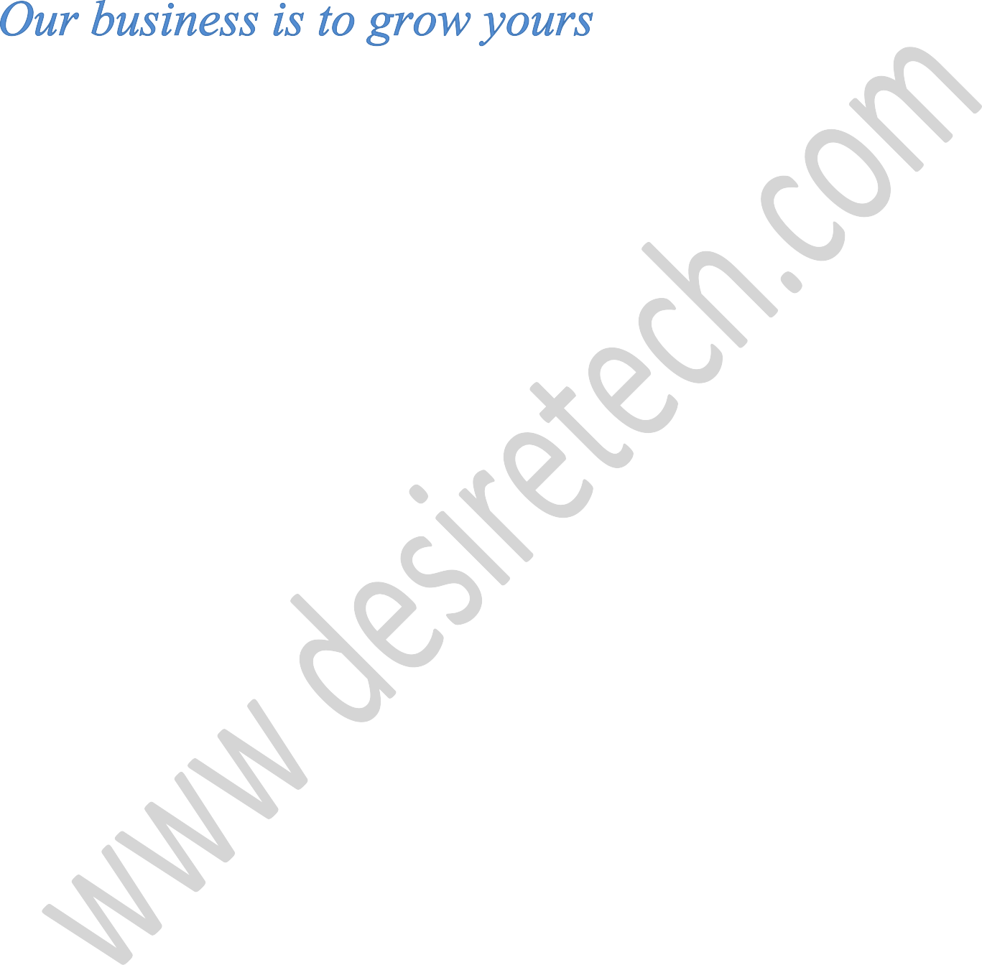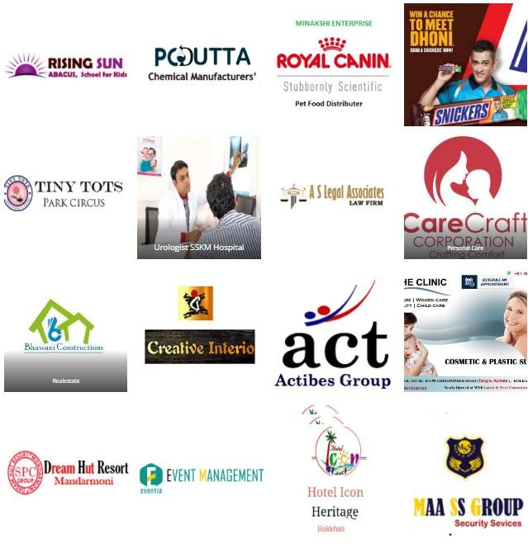We grow our clients’ businesses by giving brands an Emotional Advantage.

Truly honored to receive

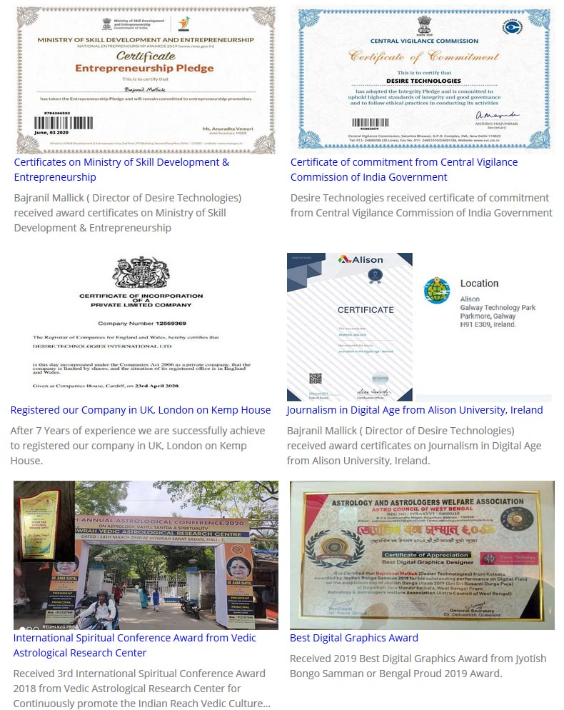

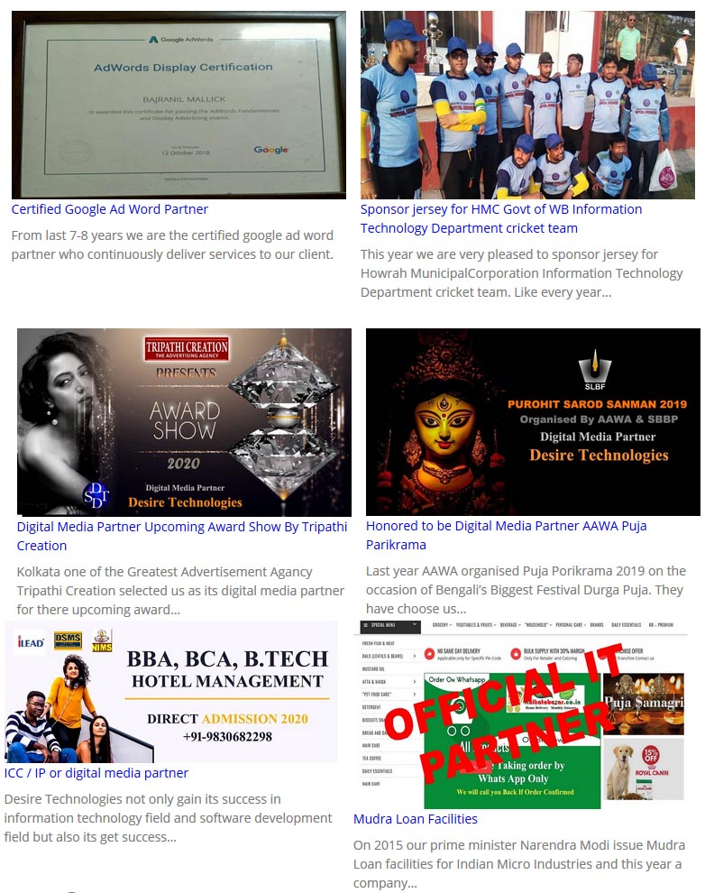

What We Do? (Mobile App Development)
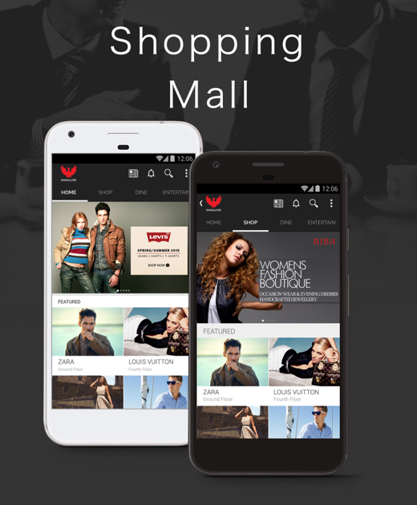

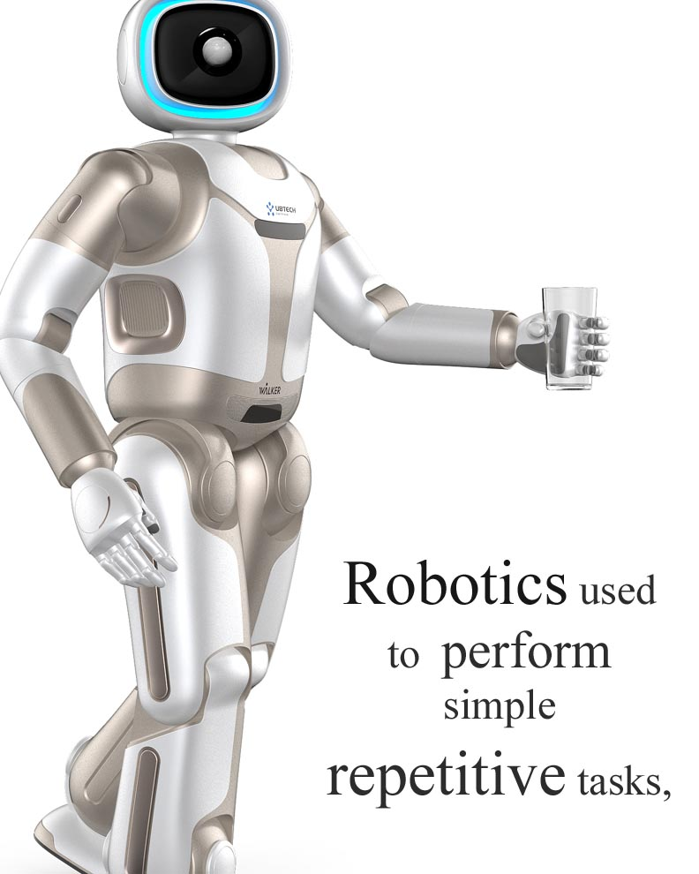
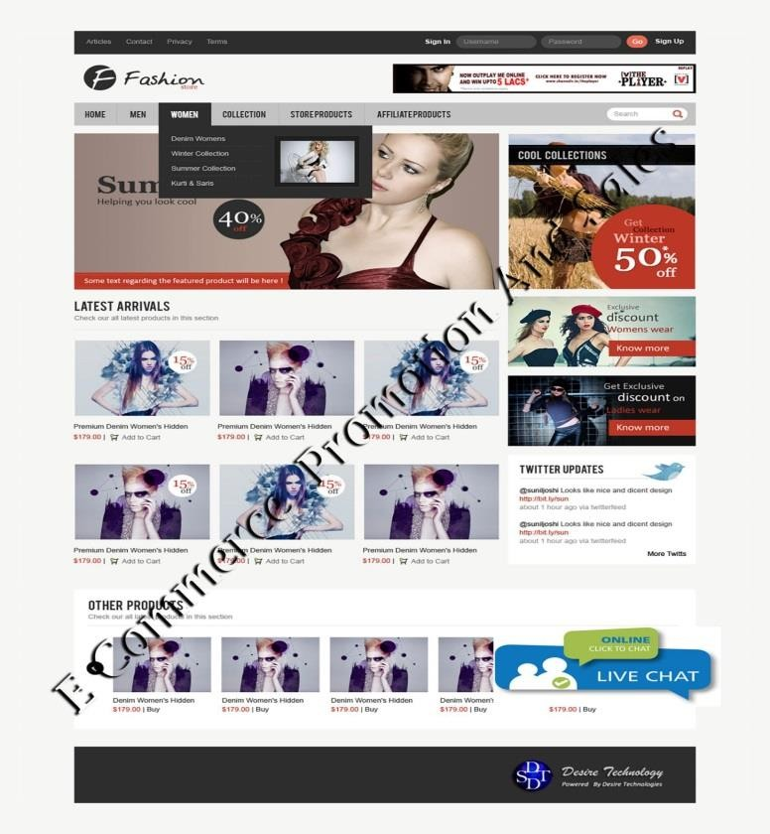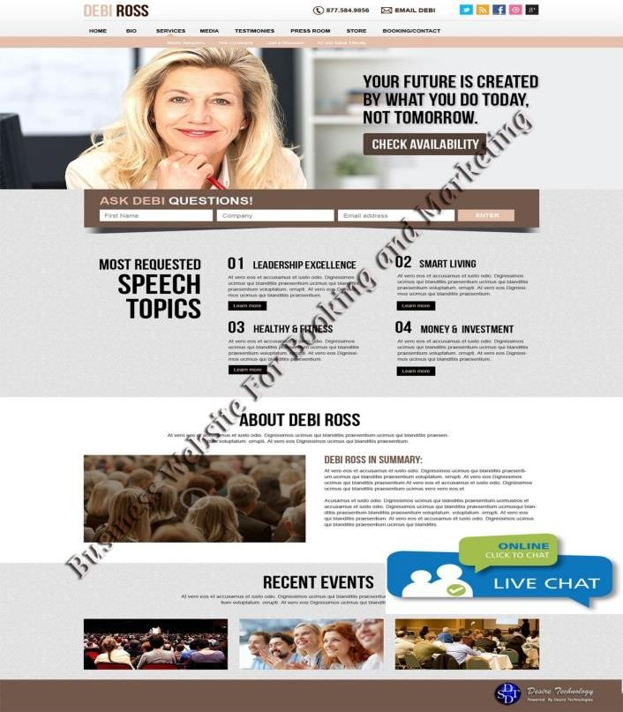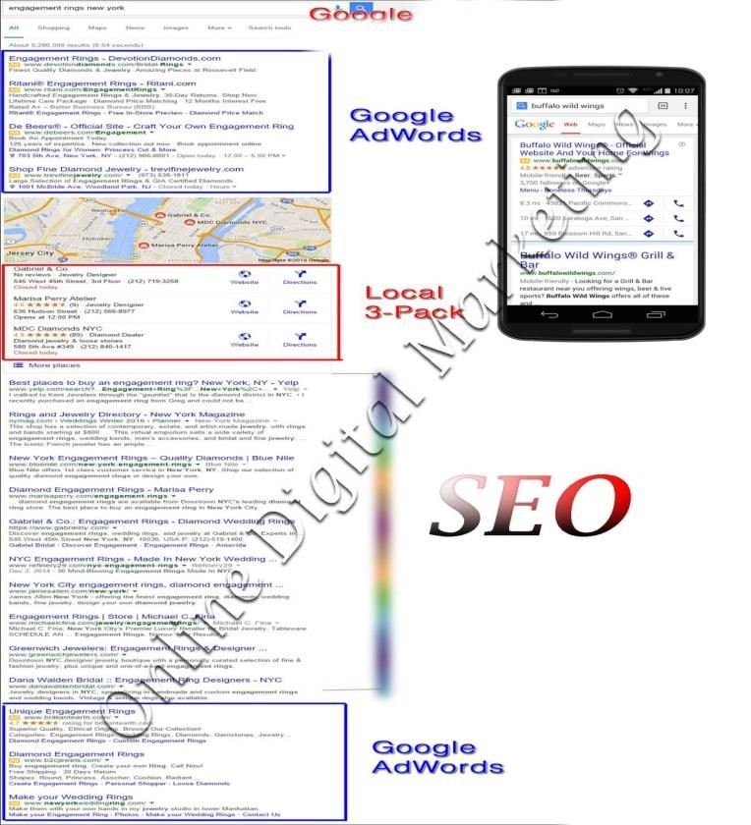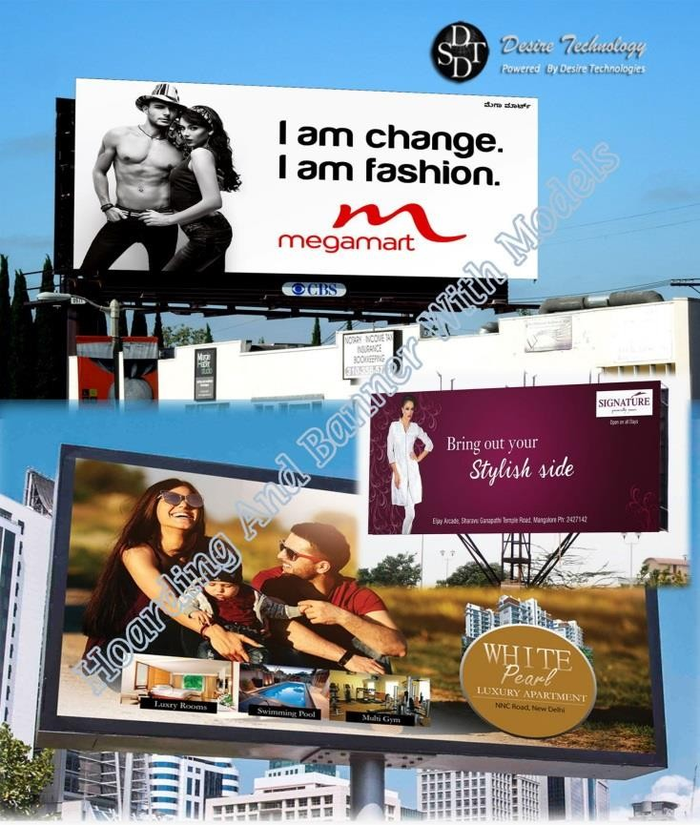

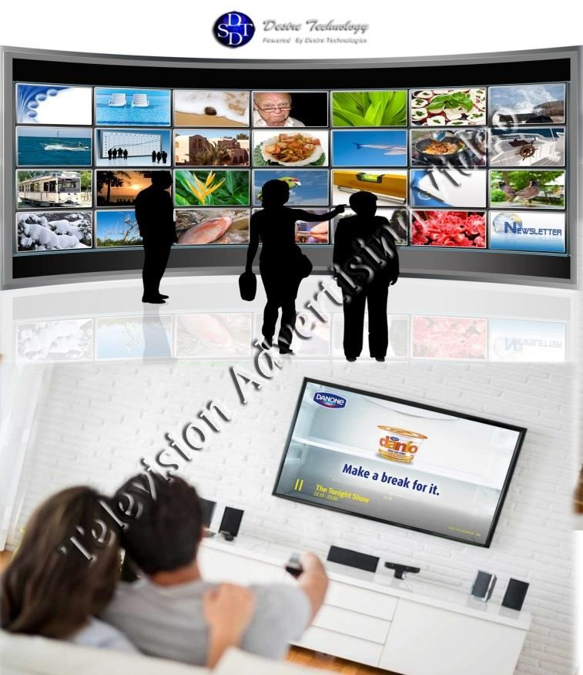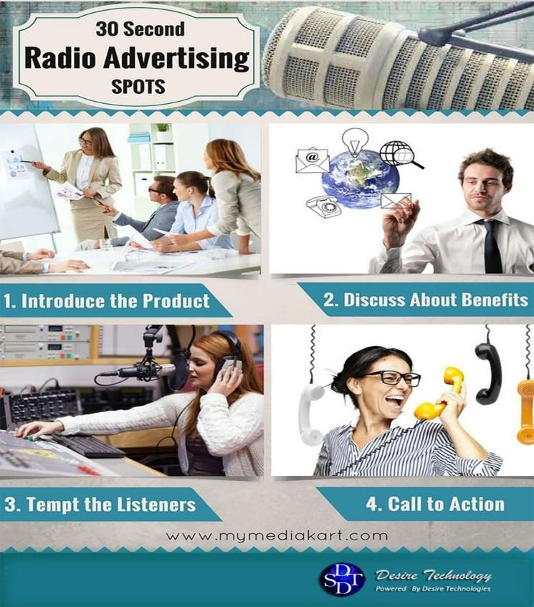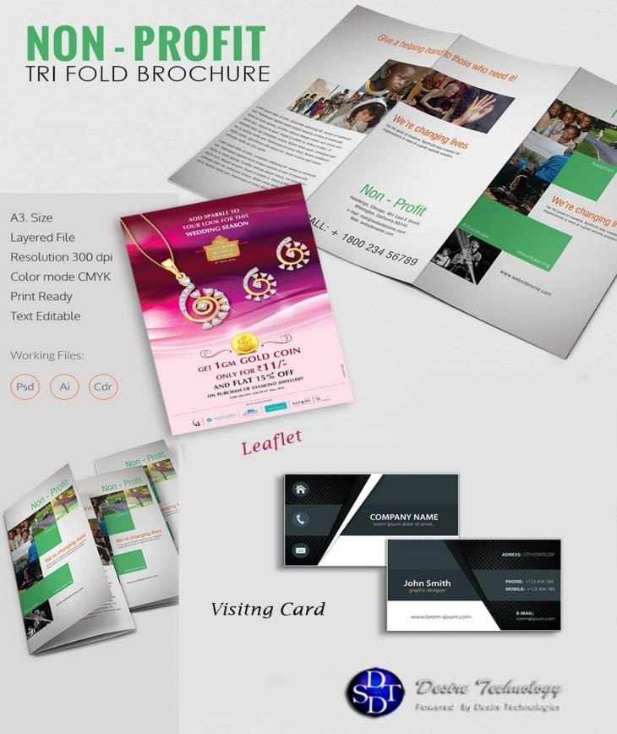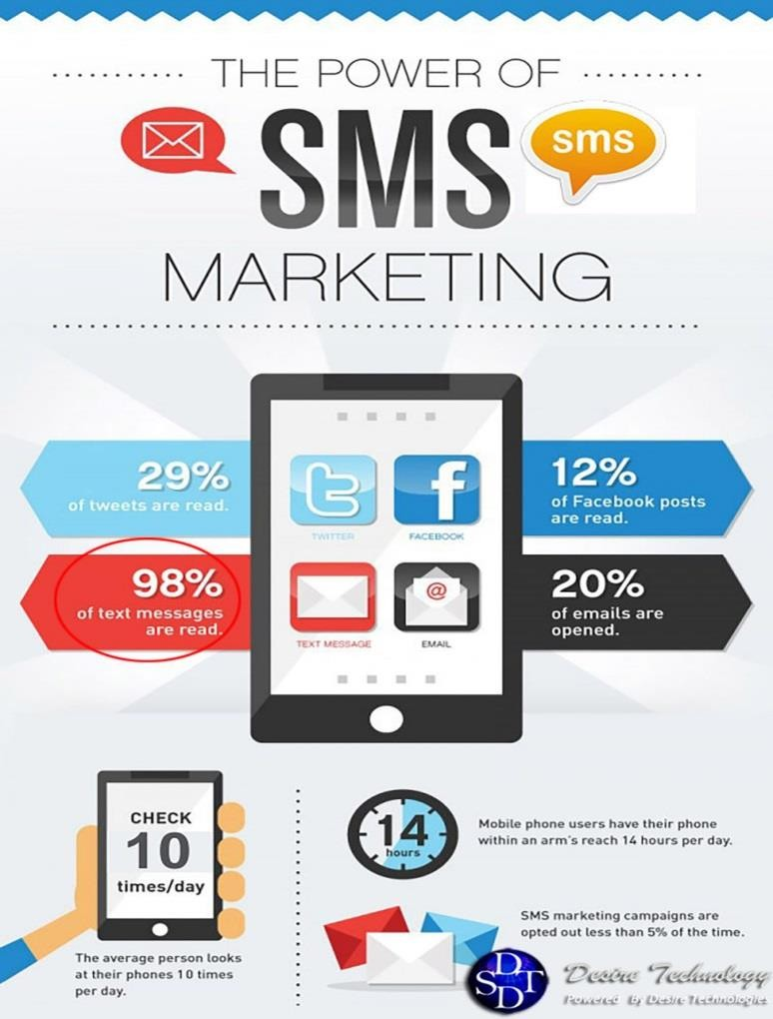

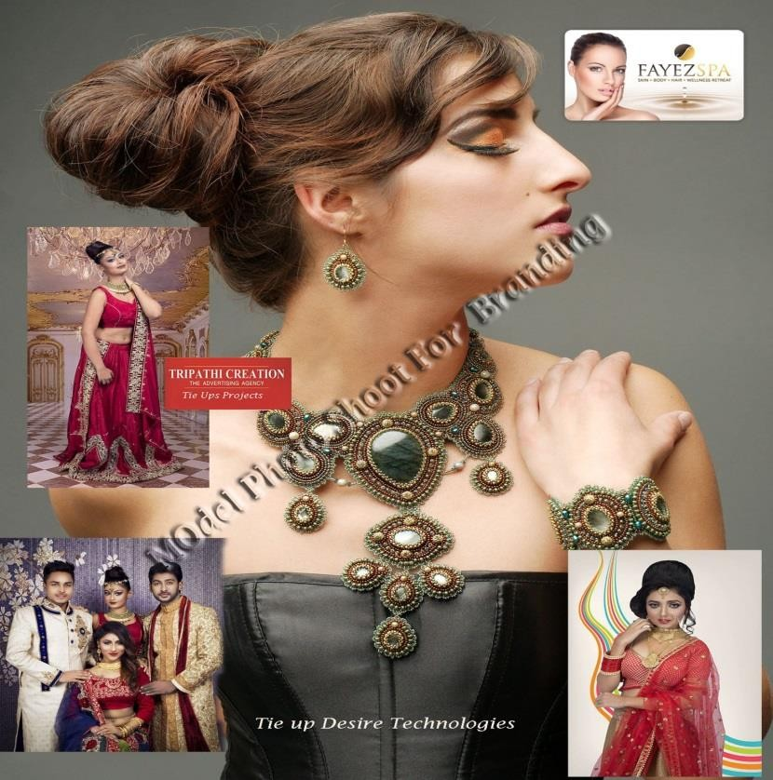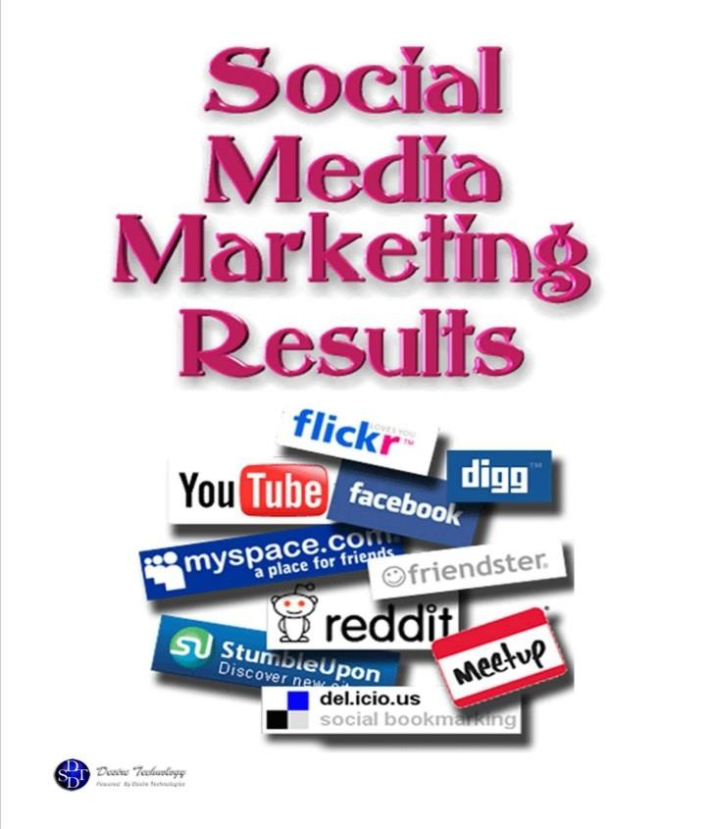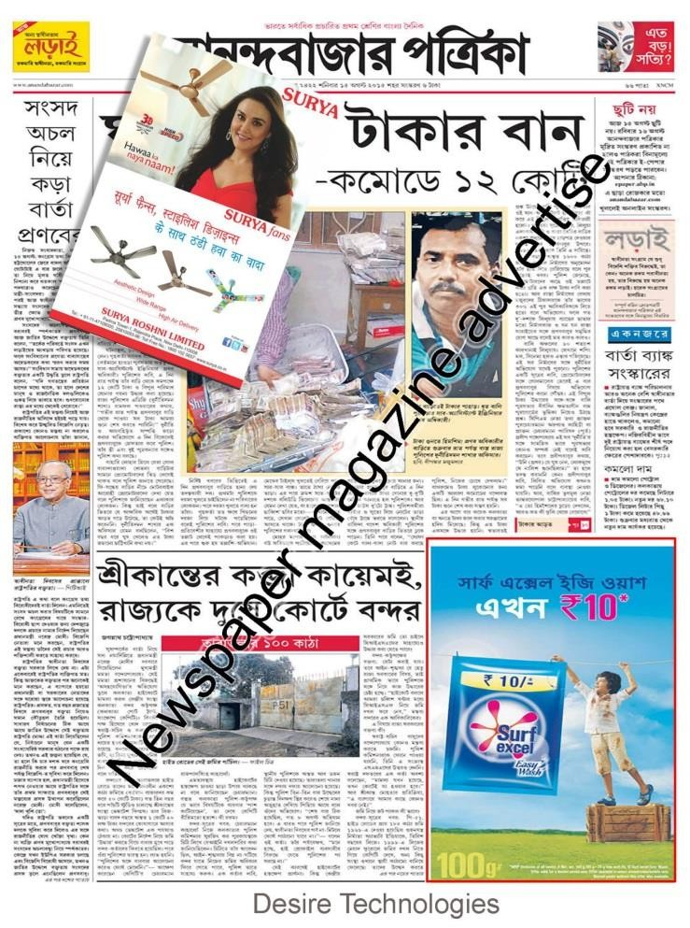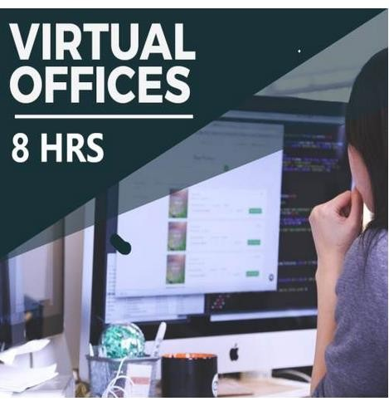

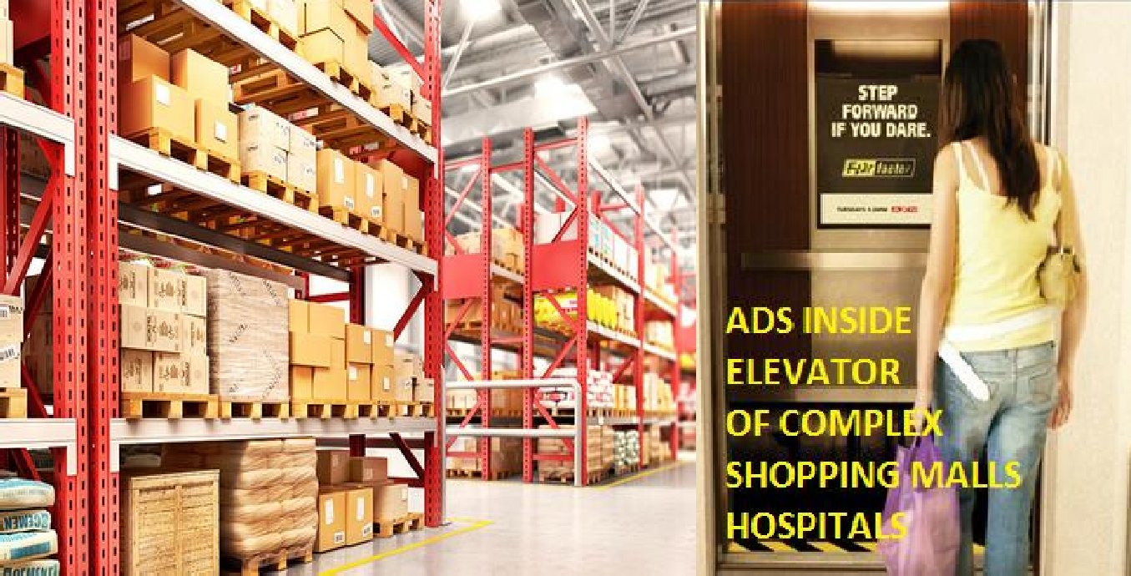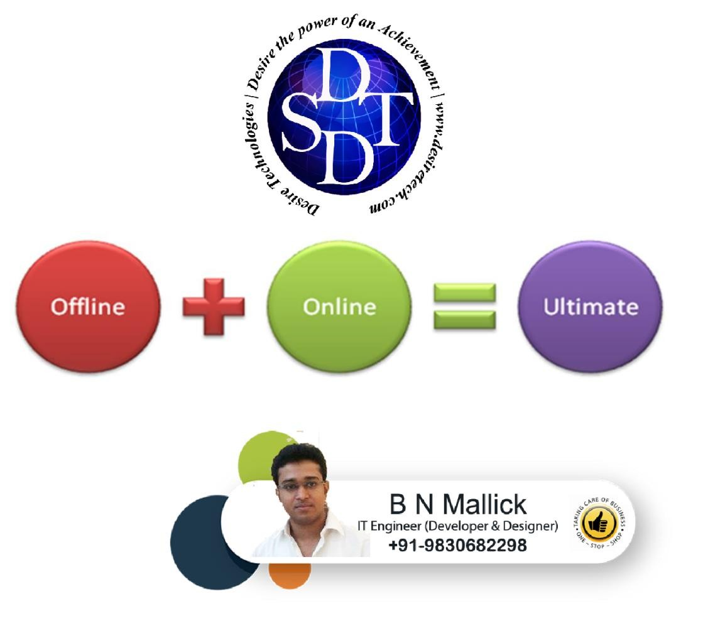warehousing

- Big Hording In Some Popular Area Like Ultandanga , Gariahat, Airport Vip Road, By Pass, Mg Road Road Etc. – Per Hording With Led

Rs. 60000/- To Rs. 100000/- 20ft * 10ft Approx.
Rs. 120000/- To – Rs.250000/- 40 Ft. * 40 Ft. Approx.

- Kmc Tax Will Be Taken As Per Municipality Rules.

- Model And Product Photo Shoot , Videos For Advertising Male Female With Makeup & Studio Charge & Photographer Charge

Rs. 10000/- (Onwards)

- E Commerce Website Plus Mobile Apps

Rs. 9999 /- ( Onwards) Native App Minimum 50000/-

- Digital Online Marketing And Seo (Search Engine Optimization) Including Google Front Page Facebook ,Twitter, Youtube Etc.Promotion

Rs. 4999/- Per Month (Onwards).

- 24*7 Live Support System On Behalf Of Your Company To Your Client

Rs 2000/- Per Month ( Onwards).

- Internet Ads Like Facebook And Others

Rs 1999/- (Onwards)

- Bulk Sms

Rs. 15-60 Paisa (Onwards).

- Television Ads

Rs 2000 Per 10 Sec (Onwards)
Rs 50000/-Per 10sec (Onwards) ( Advertisement In Between Popular Tv Program In Star Plus, Colors Etc )
Rs 10000/- For 10sec (Onwards) (Local Channel Ie Zee Bangla, Star Jalsa)
Rs 2000/- (Onwards) (National And Domestic News Channel For 10sec )
At Length Minimum 10 Sec , Frequency 5 Spot Per Days ( Minimum 7 Days )

- Radio Ads

Rs 500 Per 10sec (Onwards) Local

- Newspaper Ad Like Anadabazar Pratika , Telegraph –
Rs 6000/- Onwards Per 100 To 150 Character In Metro City And Rs 1000/- (Onwards) Per 100 To 150 Character In District
Rs 7000/- Per 15 Sq Cm Times Of India , Hindustan Times , Aajkal, Statesman – ( In Kolkata And Any Other Metropolitan City) Approx

Special Ads Like Full Page , Extra Page Ads Cost Is Completely Depends Day To Day Rate.

- Complex Lift
Promotion Inside And In Between Complex Shopping Mall Hospital’s Lift
Rs. 5000 To Rs. 20000 Monthly ( Onwards)

- Leaflet Distribution

Rs 10000/- (Onwards) For One Time Cover 1000 Shop And 10000/- People Daily 6 To 7 Hrs

- Ola Uber Ads :
Budget Varies Car Wise

Product Launching And Promotional Event :
Budget Varies Eventwise.

- Direct Sales Person Hire Shop To Shop Dorr To Door

Rs. 10000/- Per 100/- Shop Monthly Onwords

- Warehousing :

We provide warehouse in kolkata for the company who want to store their products permanently and temporary basis in kolkata for distribution . Our warehouses is situated in prime location like central kolkata sealdah and burrabazar . All transport and logistic company are available near our warehouse location. Warehouse For Storages 100-150 Sqft –

Rs 10000/- (Monthly) Onwards And Minimum 6 Month Agreement .

- Logistic :
We Have Logistic Facilities For Your Business In Our Local Area . We Have Maruti Van, Scooter, Bike, Chota Hati.
Rate Of Chota Hati Per Km

Rs 30/- Onwards Or Rs. 8 Per Min Onwards

DESIRE TECHNOLOGIES
106/2B Raja Ram Mohan sarani (Amherst Street) ,Kolkata- 700009, West Bengal, India
DESIRE TECHNOLOGIES INTERNATIONAL LTD
UK (London)
www.desiretech.com
+91-9830682298

